Assignment No -: 04

Que 1-: Select command that produces order number, amount, date for all rows in the orders table.

kd2_83598>select onum,amt,odate from orders;

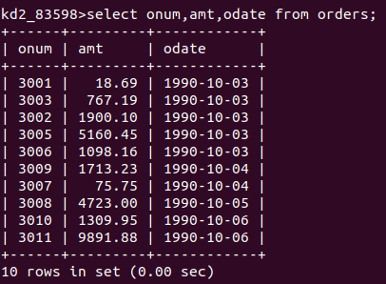

que 2-: Write a query that Produces all rows from the customers table for which the salespersons number is 1001.

kd2_83598>select *from Customers
-> where snum=1001;

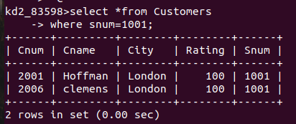

que 3 -: write a query that displays the salespeople table with the columns in the following order city,sname,snum,comm.

kd2_83598>select city,sname,snum,comm from salespeople;

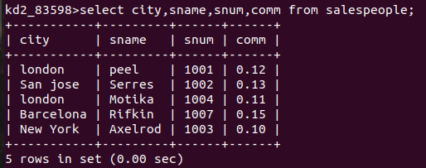

Que 4 -: Write a select command that produces the Rating followed by the name of each customer in san jose.

kd2_83598>select rating from Customers
-> where City='San Jose';
